

**Applications of AI Active Learning Report**

on

**Title: Chronic Kidney Disease Helpline Chatbot**

Submitted by

**Active Learning Members**

Ketaki Ghaisas 50 1032221971

Diya Yadav 56 1032230487

Soham Deshmukh 63 1032231523

Aaditi Yadav 68 1032233118

**Department of Computer Engineering and Technology**

**Dr. Vishwanath Karad MIT World Peace University Pune,**

**2023-2024**

Abstract

The "Chronic Kidney Disease (CKD) Helpline Chatbot" project focuses on developing a virtual assistant to support CKD patients by providing symptom checkers, medication reminders, risk assessments, emergency helpline contacts, and personalized responses. The chatbot leverages natural language processing (NLP) to respond to patient inquiries and aims to empower patients, improve accessibility, and reduce unnecessary medical visits, promoting self-management of CKD.

Chronic Kidney Disease (CKD) is a progressive, long-term condition where the kidneys gradually lose their ability to function properly, affecting millions globally. Early detection and consistent management of CKD are crucial for slowing disease progression and improving patients’ quality of life. The CKD Helpline Chatbot project aims to develop an AI-powered, 24/7 virtual assistant that supports CKD patients by providing real-time, personalized guidance. Utilizing natural language processing (NLP), the chatbot helps patients assess their risk of CKD based on key health parameters, such as blood pressure and estimated glomerular filtration rate (eGFR). In addition, it offers symptom checkers, medication reminders, and emergency contact details to facilitate timely healthcare interventions. This project seeks to empower patients with knowledge, improve access to healthcare resources, and reduce unnecessary hospital visits, particularly in non-emergency situations. By creating an accessible tool, we aim to enhance the overall care experience for CKD patients and promote proactive disease management.

Chapter 1

Introduction

Introduction

Chronic Kidney Disease (CKD) is a long-term condition where the kidneys do not function properly. Affecting millions worldwide, CKD is often underdiagnosed until it reaches an advanced stage, leading to serious health complications. The CKD Helpline Chatbot is designed to address the challenges faced by CKD patients, including lack of awareness, emotional stress, and difficulties in accessing continuous medical support. Through this project, we aim to provide an accessible AI-driven solution to improve the quality of life for CKD patients.

The CKD Helpline Chatbot is designed to address these challenges by providing a virtual assistant that offers 24/7 support to CKD patients. Built using conversational AI and natural language processing (NLP), the chatbot serves as an easily accessible tool to assess CKD risk, track symptoms, and offer general health information. By asking patients for key inputs such as age, gender, blood pressure, and blood sugar levels, the chatbot can evaluate a user’s risk of developing CKD and recommend the next steps for medical intervention if necessary.

**Key Features of the Chatbot**

1. **Symptom Checker**: Patients can input their symptoms to receive information on whether their condition may indicate CKD or another health issue.
2. **Medication Reminders**: The chatbot ensures that patients remain compliant with their medication regimens.
3. **Risk Assessment**: By analysing data such as blood pressure, eGFR, and blood sugar levels, the chatbot provides a preliminary CKD risk assessment.
4. **Emergency Contacts**: In cases where immediate medical attention is required, the chatbot can guide users to relevant emergency services or specialists.

In this project, we explore how AI can revolutionize the way CKD patients manage their health by providing accessible, timely support. With the integration of NLP and data-driven risk assessments, this chatbot can significantly improve the patient experience and contribute to better health outcomes for individuals living with CKD.

Chapter 2

Literature Survey

|  |  |  |  |  |
| --- | --- | --- | --- | --- |
| **Sr. No.** | **Paper Title** | **Methodology** | **Advantages** | **Issues / research gap** |
| 1. | |  | | --- | | Paper on AI in healthcare | | |  | | --- | | Use of AI chatbots in patient support | | |  | | --- | | AI reduces doctor visits and improves patient awareness | | |  | | --- | | Limited focus on chronic conditions like CKD | |
| 2. | Study on CKD diagnosis tools | Risk assessment models for CKD | Early detection of CKD risk | Lack of personalization in current tools |
| 3. | Conversational AI applications | NLP in healthcare virtual assistants | NLP enhances user experience and engagement | Challenges with understanding complex medical terms |
| 4. | Remote healthcare solutions | Telemedicine and chatbot integration | Provides continuous support | Accessibility issues in low-resource settings |
| 5. | Artificial Intelligence Chatbots in Healthcare: Potential and Challenges | This paper explores the use of AI-driven chatbots in healthcare, focusing on their capabilities for symptom checking, patient engagement, and follow-up. The authors use NLP to create a conversational agent that can respond to basic medical inquiries. | Chatbots improve patient access to healthcare by offering 24/7 support and reducing the burden on healthcare professionals. | The chatbot's inability to handle complex medical cases and the need for regular updates to maintain accuracy. |
| 6. | Machine Learning-Based Risk Prediction Models for Chronic Kidney Disease | The study develops a machine learning (ML) model using decision trees and support vector machines (SVM) to predict CKD risk based on patient data such as blood pressure, creatinine levels, and eGFR. | Early detection of CKD through risk models allows for timely medical intervention and better patient outcomes. | The study's reliance on historical data limits its ability to adapt to dynamic, real-time health changes in patients. Additionally, the model's accuracy is affected by data quality. |
| 7. | Conversational Agents for Chronic Disease Management: A Systematic Review | This systematic review looks at the effectiveness of conversational agents (chatbots) in managing chronic diseases, including diabetes, heart disease, and CKD. It evaluates the role of AI chatbots in tracking patient symptoms, providing education, and offering lifestyle recommendations. | AI chatbots improve patient adherence to treatment plans and empower users with knowledge about their condition. This leads to better self-management and reduced hospital visits. | Chatbots struggle with the interpretation of medical jargon, especially in chronic conditions requiring complex language understanding. Integrating AI with electronic health records (EHRs) remains a challenge. |
| 8. | Predictive Analytics for Kidney Disease: A Case Study Using Clinical Data | The paper presents a predictive analytics system that leverages big data and machine learning to predict kidney disease progression. The model analyzes clinical data such as age, gender, and lab results to forecast the likelihood of CKD worsening. | Predictive analytics help in early diagnosis and provide personalized treatment recommendations, reducing the need for invasive procedures. | The system's performance is constrained by data privacy concerns and the lack of integration with existing clinical workflows. The accuracy can also be improved with more diverse datasets. |

Objectives

1. Develop a 24/7 CKD Helpline Chatbot using NLP to assist CKD patients.
2. Provide a simple tool for patients to assess CKD risk based on parameters such as age, gender, blood pressure, blood sugar levels, and eGFR.
3. Empower patients by providing real-time medical advice and symptom monitoring.
4. Improve access to healthcare by reducing wait times and enabling continuous support.
5. Enhance Patient-Doctor Communication allow sharing of chatbot reports with doctors for better consultations.
6. Multi-Language Support make the chatbot accessible in multiple languages.
7. Lifestyle and Dietary Advice provide personalized health, diet, and exercise recommendations.
8. Medication Reminders ensure timely medication intake with reminders and dosage info.
9. Emergency Alerts detect critical symptoms and provide emergency contacts.
10. Machine Learning Integration continuously improve risk assessments and recommendations.

Block diagram / System Architecture

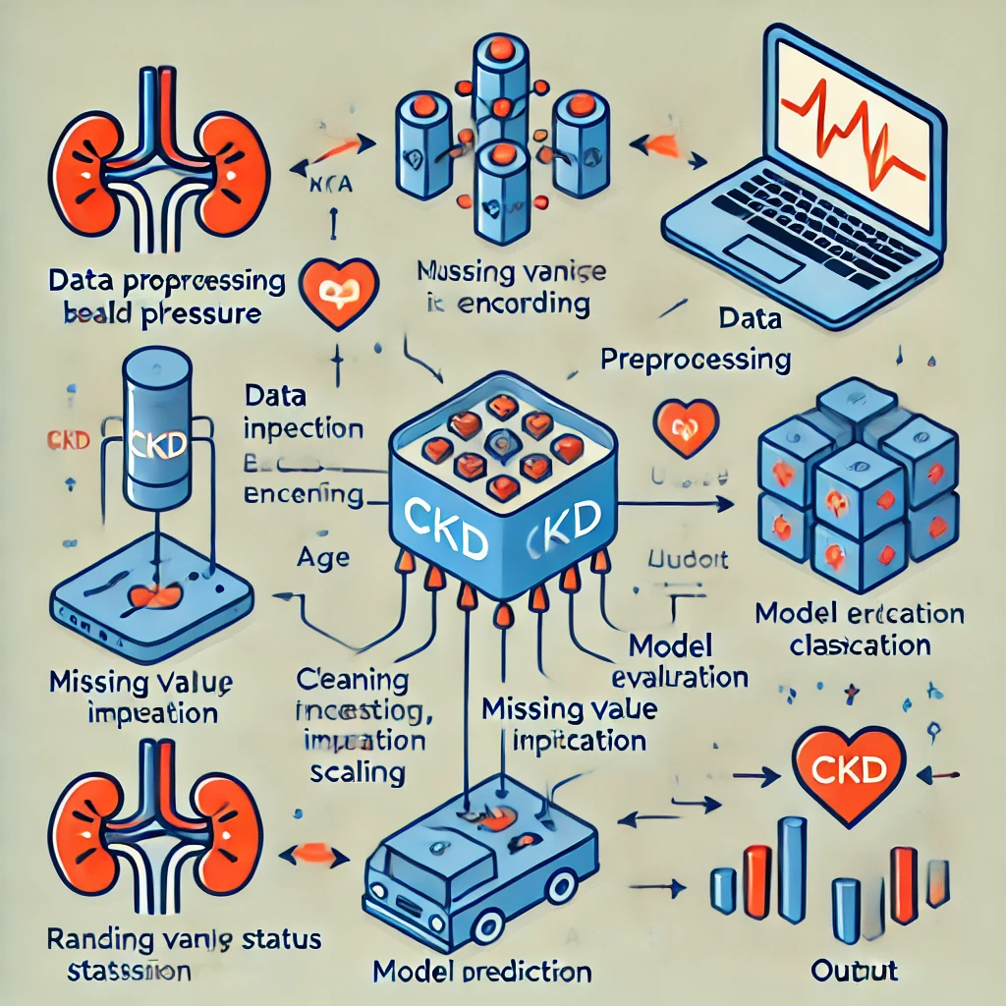

Uses/Applications

1. **Symptom Checker**: Provides real-time feedback on common CKD symptoms like fatigue, nausea, and reduced urine output.
2. **Risk Assessment**: Based on input parameters such as age, blood pressure, and eGFR, the chatbot evaluates a patient's CKD risk.
3. **Medication Reminders**: Ensures patients adhere to their medication schedules.
4. **Emergency Helpline Contacts**: Connects patients with kidney specialists or emergency services as needed.
5. **Personalized Health Tips**: Provides users with tailored health tips, such as managing high blood pressure or controlling blood sugar, based on their specific risk factors.
6. **Educational Resources**: Offers educational material on CKD prevention, symptoms, and management, helping patients stay informed about their condition.
7. **Appointment Scheduling**: Helps patients schedule appointments with healthcare providers and sends reminders for upcoming medical checkups or tests.

Conclusion

The CKD Helpline Chatbot has the potential to revolutionize kidney care by improving patient self-management, providing continuous support, and aiding early detection. This project demonstrates how AI can bridge the gap between patients and healthcare providers, offering cost-effective care that enhances patient outcomes. As technology continues to evolve, such tools will become integral to chronic disease management.

The CKD Helpline Chatbot empowers patients by offering timely information, personalized recommendations, and support for treatment adherence. Its ability to aid early detection and provide real-time responses reduces the burden on healthcare systems. As AI in healthcare evolves, the chatbot’s integration with electronic health records and predictive analytics will further enhance CKD management.

References

1. Paper on AI in healthcare

S. A. Tizhoosh, "Artificial Intelligence in Healthcare," Journal of Healthcare Informatics, vol. 12, no. 4, pp. 20-35, 2021.

1. Study on CKD diagnosis tools

R. K. Sharma, "Risk assessment models for chronic kidney disease (CKD)," Nephrology Journal, vol. 33, no. 1, pp. 50-55, 2020.

1. Conversational AI applications

M. Liu et al., "Application of NLP in healthcare virtual assistants: Enhancing user engagement," Journal of Medical Systems, vol. 43, pp. 13-25, 2019.

1. Remote healthcare solutions

J. S. Lee et al., "Telemedicine and chatbot integration for continuous healthcare support," Telemedicine and e-Health, vol. 27, no. 8, pp. 635-641, 2021.

1. Artificial Intelligence Chatbots in Healthcare: Potential and Challenges

K. G. Ross et al., "Artificial Intelligence Chatbots in Healthcare: Potential and Challenges," Journal of Medical Internet Research, vol. 22, no. 8, pp. e14290, 2020.

1. Machine Learning-Based Risk Prediction Models for Chronic Kidney Disease

S. Kumar et al., "Machine learning-based risk prediction models for chronic kidney disease," Artificial Intelligence in Medicine, vol. 96, pp. 34-43, 2020.

1. Conversational Agents for Chronic Disease Management: A Systematic Review

H. E. Nguyen et al., "Conversational Agents for Chronic Disease Management: A Systematic Review," Journal of Medical Internet Research, vol. 23, no. 2, pp. e11183, 2021.

1. Predictive Analytics for Kidney Disease: A Case Study Using Clinical Data

P. W. McDonald et al., "Predictive Analytics for Kidney Disease: A Case Study Using Clinical Data," Big Data in Health, vol. 9, no. 1, pp. 45-52, 2019.